**CMSC 733 HW0**

UID: 118339238 Name: Young-Shiuan Hsu

1. Plot the RGB values along the scanline on the 250th row of the image.

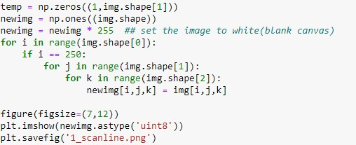

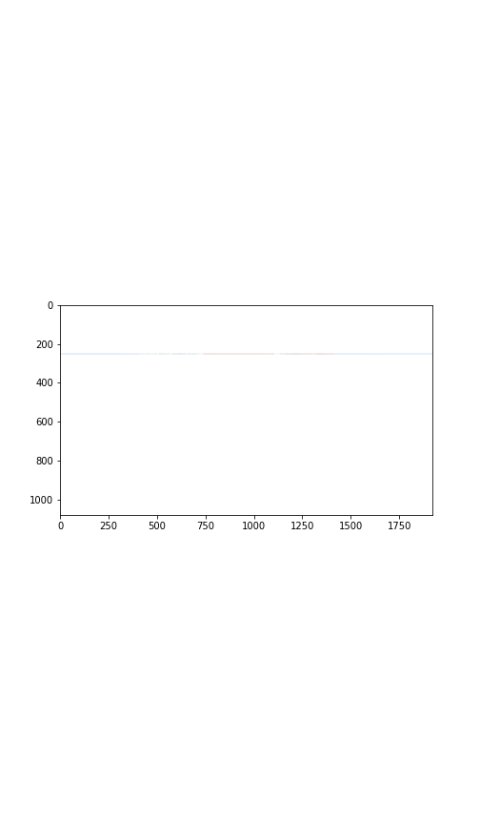

1. Stack the RGB channels of the image vertically

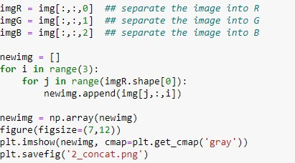

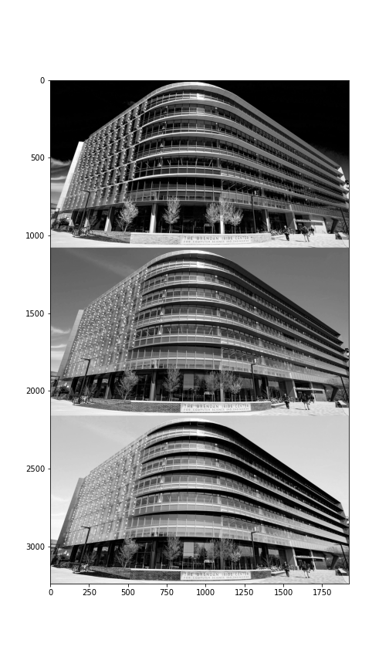

1. Swap red and green color channel

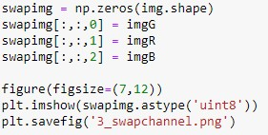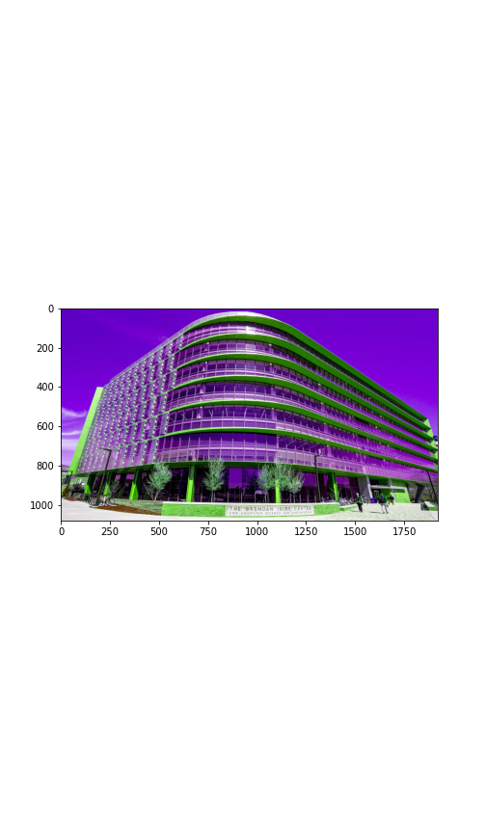

1. Load the input color image to the grayscale image

We use a certain formula to convert an RGB image into a gray scale image.

New grayscale image = 0.3*R + 0.59*G + 0.11*B

Reference website:

<https://www.tutorialspoint.com/dip/grayscale_to_rgb_conversion.htm#:~:text=You%20just%20have%20to%20take,Its%20done%20in%20this%20way>

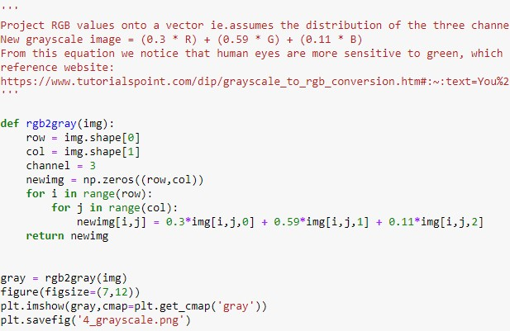

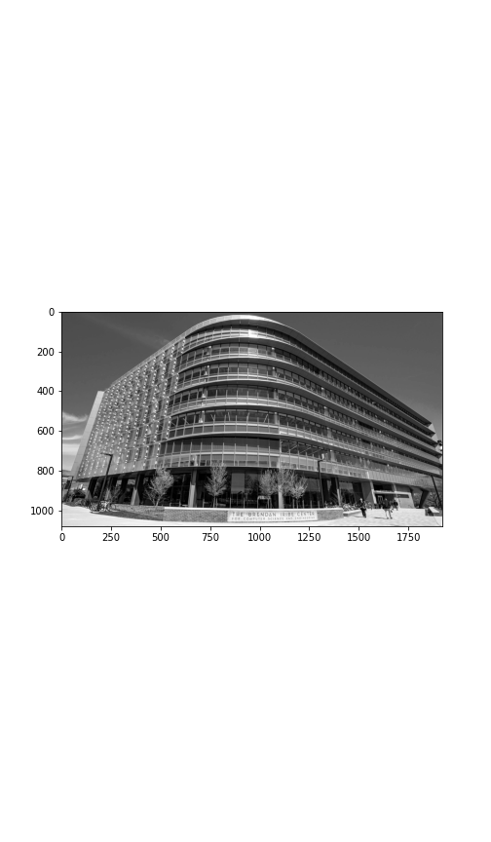

1. Compute the average value of the RGB values over the three channels

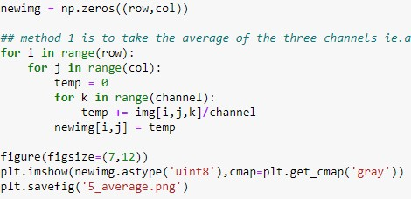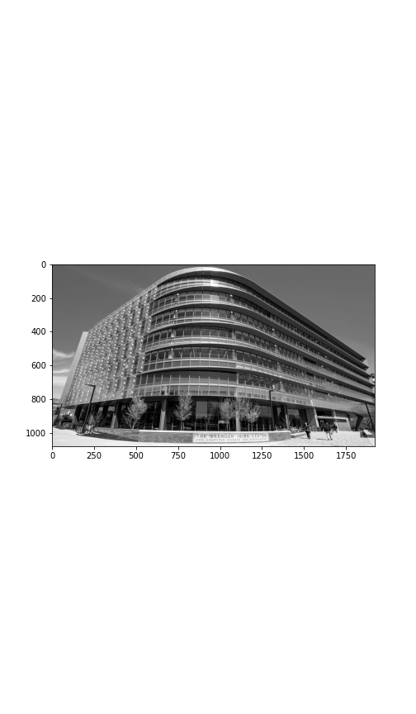

1. Negative image of the grayscale image from problem 4

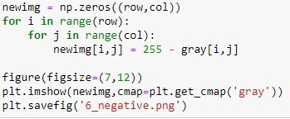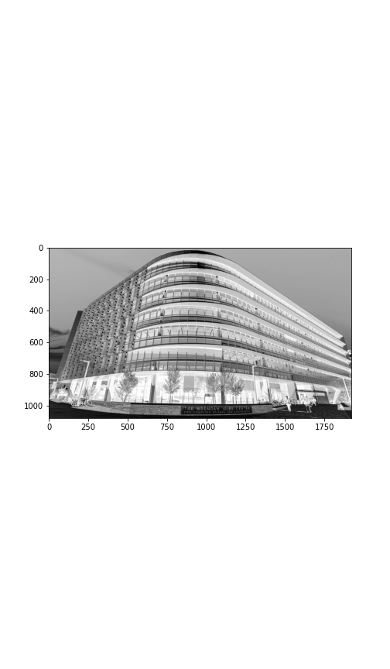

1. Crop the image to 372*372, then rotate the image by 90,180 and 270 degrees

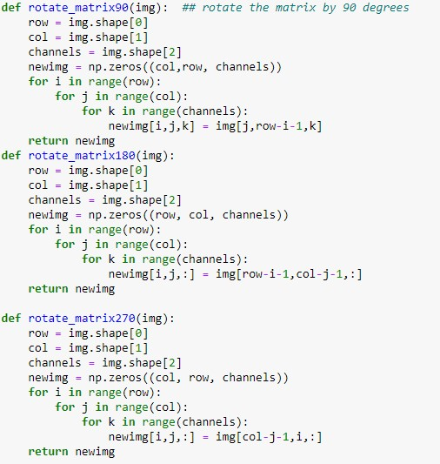

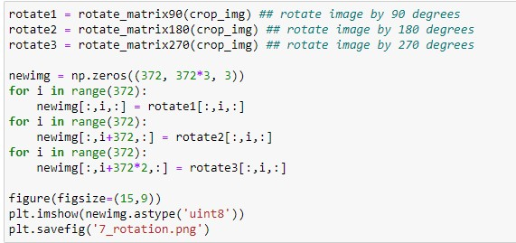

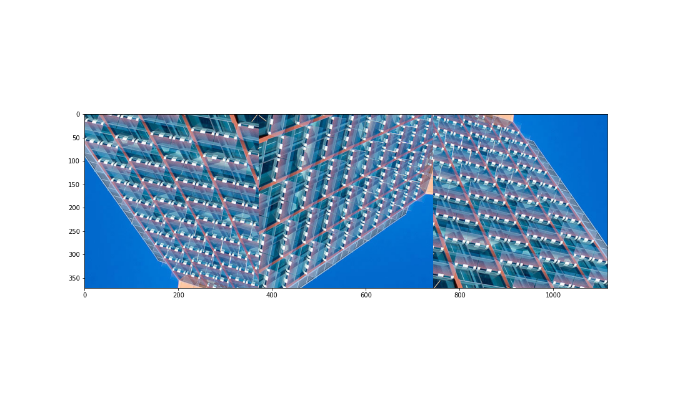

1. Set the pixel values that are greater than 128 to 255

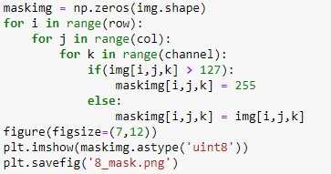

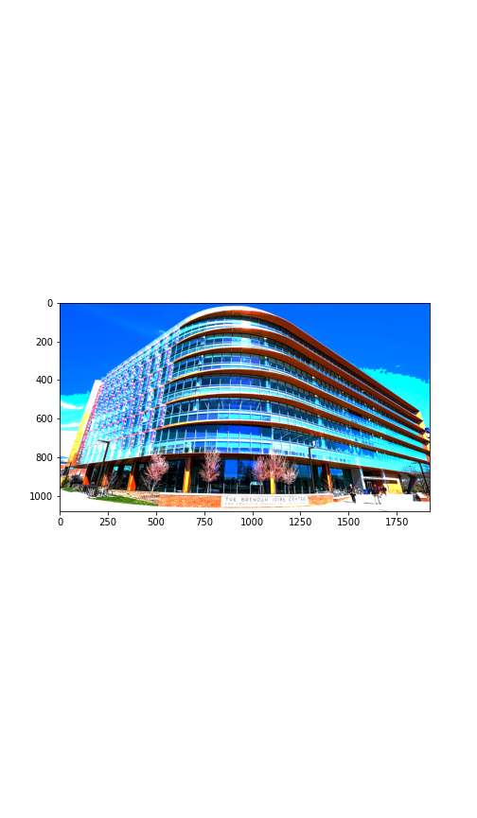

1. The mean of the RGB values of the masked image in problem 8

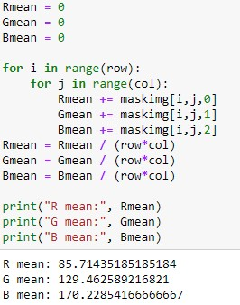

1. For every 5*5 patch, find the maximum value in the patch and set it to 255

Note: if there are multiple pixels in the 5*5 kernel that is equivalent to the maximum value we set them all to 255

